Numba Documentation.

What is numba?

Numba is a JIT (Just In Time) Compiler, which will convert your normal python code into optimized machine code at runtime.

Numba helps us to achieve the execution speed near to that of the other programming languages such as C or Java.

This is done by automatic detection and assignment of appropriate datatypes during the compilation of the programs, which is not present in python.

Numba works well with numpy arrays, which contains huge number sets, making it suitable for scientific computation.

Numba codes can be used to parallelize threads and could also be
used to run in GPU if the workload demands.

Advantages of using numba:
- The execution time of the program is nearly 10 to 100 times faster using Numba after the first* execution.
- Numba makes use of parallelized processing for faster execution of the process.
- No need to learn or adapt any code. It will just run on normalized python codes.

Disadvantages of using numba:

- During the intitial compilation, the execution time of the function will be equal or more than the time taken during the execution of normal python function
- Numba is not very good with datatypes it is NOT based upon. Eg. (Numba will revert back to normal python execution when it encounters STRING during computation).

How Numba Works?
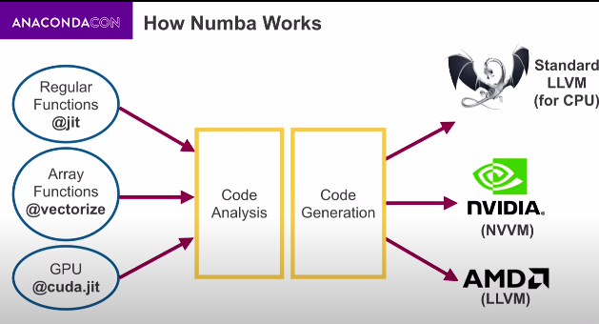
Process Involved:
- The code is analysed for functions and arrays or any other compatible mathematical functions.
- It is fed into the code generation which is used to segreate the functions and methods based upon thier datatypes.
- The CODE GENERATION redirects the code to the needed hardware computation part. [CPU, GPU etc] .

Compilers available for Numba:

@jit: Regualar Functions.
@vectorize Numpy functions
@guvectorize: Numpy Generalized functions
@stencil Neighbourhood calculations
@cfunc C Callbacks
@cuda.jit NVIDIA GPU controls
@roc.jit AMD Radeon GPU controls.

When to use the NUMBA?
1. To run your numeric calculations faster.

